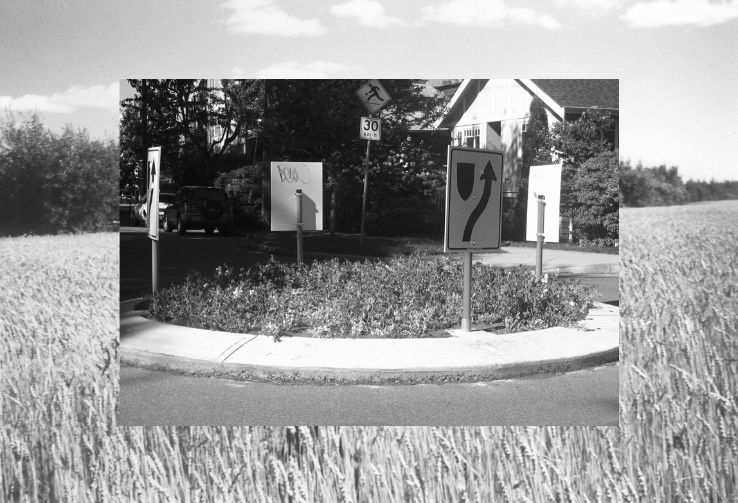

Garden Gnomad

is a dialogic and documentary work-in-progress about urban agriculture.

Dialogic – the Garden Gnomad visits sites of urban agriculture (community gardens, urban farms, other urban-based food producers) to have conversations with growers and to document their innovations & inquiries as artworks or objects for exchange (postcards).

Documentary – Images of the gardens, audio recordings of the dialogue, video or film of garden advocacy or education, and other findings will be manipulated by the Garden Gnomad machinery into artworks & garden propaganda at Means of Production Community Garden events and other garden forums (eg. ‘The Great Farm Trek’ to save UBC Farm).

Farm Machinery – The Garden Gnomad is a portable documentation machine made of a recycled laptop that runs a Gnome desktop on the Ubuntu 8.10 – Linux operating system. The computer has a unique image labeling and collaging program that has been developed by Lois Klassen and Dominik Pokorny at the Banff New Media Institute.
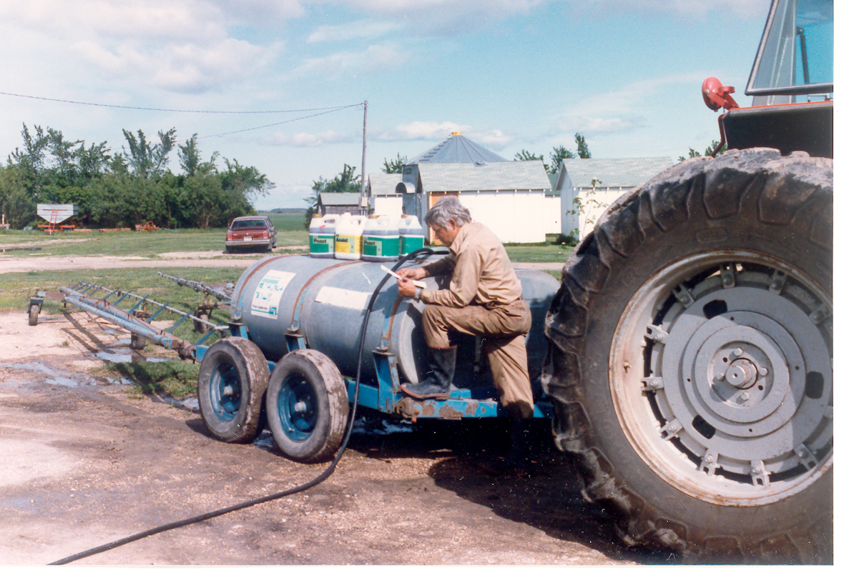
Garden Gnomad also has a small printer, audio recording equipment, measurement tools like thermometers, measuring tapes, pollination observation forms, and other materials related to garden or farm observation that become available to the Garden Gnomad during its travels. A battery/inverter unit fueled by umbrella-mounted solar panels powers all of the equipment.

Influential & remarkable artworks about roaming, documenting and eating in the city -

- Rebecca Belmore’s Ayum-ee-aawach Oomama-mowan: Speaking to Their Mother as a model for nomadic dialogue facilitated by an awkward tool.
- Foncie Pulice’s long career (40+ years) of street photography in Vancouver using a cart fashioned from war & movie industry surplus.
- Martha Aitchison’s Shopping Trolley Gallery a shopping trolley of mail art (mostly postcards) craftily constructed and exhibited in and around the town of London from 1996-2007.
- Kevin Hamilton’s Monument to Everyday Deaths. A so far unrealized project to mark the deaths of members of the public, with a publicly available photograph of a patch of green grass taken by a fixed webcam.
- Farmlab, in LA for using agricultural forms as art-interventions in threatened public spaces; and for building public dialogue into their work.
- Mike MacDonald’s butterfly gardens that grew from and were integrated with his video documentation work; his work is a model of environmental and cultural integration through media art.
- Emergent urban farm practices like “Spin Farming” (Saskatchewan), “The City Farm Boy” (Vancouver) and Freedom Gardens (in progress) for looking for viable options for food production in existing sites, with existing human and space resources.
- Fritz Haeg for his charismatic mission to garden where gardening is radical.
- Katalog’s (Sarah Lewison) Case Study: Olympia’s Free Tap, a work that illustrates how documentation of a resource (video footage of the free ‘commons’ water tap in Olympia) can reinforce a free and public relationship between urban residents and their food or water.

Lois Klassen, BNMI Liminal Screen Residency, 2009
http://gardengnomad.wordpress.com
Box 74540 Vancouver V6K 4P4
loiszing@telus.net

